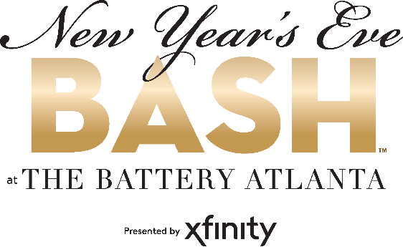
For more information:
Sarah Wynn Benton
BRAVE Public Relations
404.233.3993
sbenton@emailbrave.com
*MEDIA ADVISORY*

The Battery Atlanta Celebrates the New Year with annual New Year’s Eve Bash, Dec. 31
Metro-Atlanta’s premiere entertainment destination offers happenings for families and adults to celebrate the new year

ATLANTA (Dec. 6, 2022) – Guests are invited to welcome 2023 in style at The Battery Atlanta’s annual New Year’s Eve Bash presented by Xfinity on Friday, Dec. 31. Cobb County’s favorite open-air destination will host the annual festivities in two parts, starting with Early Innings for families, followed by Late Innings for adult revelers.

The Early Inning festivities will begin at 6 p.m. with a traditional late-night show for families celebrating with children. Kids will be able to join in on the countdown before bedtime with an inflatable baseball drop at 8 p.m. and live performance from GRAMMY nominee Justin Roberts. Adults looking to ring in the New Year later in the night can enjoy Late Innings beginning at 9 p.m. with a performance from The 12 South Band at the Georgia Power Pavilion Stage. The evening will close with a midnight countdown that includes pyrotechnics and features an unforgettable firework and confetti display to light the sky above The Battery Atlanta.

WHAT: The Battery Atlanta’s New Year’s Eve Bash presented by Xfinity

WHEN: Friday, Dec. 31
Early Innings: 6-8 p.m.
Late Innings: 9 p.m.-midnight

WHERE: The Battery Atlanta
800 Battery Ave
Atlanta, GA 30339

HOW: This event is FREE and open to the public.

Connect with The Battery Atlanta on Facebook, Twitter and Instagram.
For more information on The Battery Atlanta Holiday events visit batteryatl.com.

